Plant-Derived Repellents Against Aedes aegypti for Sustainable Vector Control: A Systematic Review and Meta-Analysis

ABSTRACT
Background: Aedes aegypti is the principal vector of dengue, Zika, chikungunya, and yellow fever viruses and remains a major target of vector-control programs in tropical and subtropical regions. Plant-derived repellents have gained increasing attention as sustainable, biodegradable, and locally accessible alternatives to synthetic repellents such as DEET and picaridin. However, evidence on their comparative efficacy remains fragmented across plant species, formulation types, concentrations, and experimental settings.
Objectives: This systematic review and meta-analysis aimed to evaluate the pooled effectiveness of plant-derived repellents in reducing Aedes aegypti biting or landing rates and to identify plant categories with the strongest potential for sustainable vector-control application.
Methods: Literature searches were conducted in PubMed/MEDLINE, Scopus, Web of Science, EMBASE, and Google Scholar from database inception to March 2026. Eligible studies included laboratory bioassays, randomized experimental studies, and controlled field evaluations assessing plant-derived repellents against Aedes aegypti. Two reviewers independently performed study selection, data extraction, and risk-of-bias assessment. A random-effects meta-analysis was performed using the DerSimonian–Laird method. The main outcome was the risk ratio of mosquito biting or landing. Heterogeneity was assessed using I², Cochran’s Q, and τ². Subgroup analyses were conducted according to plant species, formulation type, and study region.
Results: Thirty studies involving 3,958 participants or bioassay units were included. Plant-derived repellents were significantly associated with lower Aedes aegypti biting or landing rates compared with controls, with a pooled RR of 0.37 (95% CI: 0.31–0.43; p < 0.001). Heterogeneity was substantial (I² = 62.4%; τ² = 0.038). Clove oil, neem oil, and lemon eucalyptus or PMD-based formulations showed the strongest protective effects. No significant publication bias was detected using Egger’s test.
Conclusion: Plant-derived repellents show promising effectiveness against Aedes aegypti and may serve as complementary tools for sustainable vector control. Further research should prioritize standardized bioassay protocols, optimized formulations, field validation, and safety assessment before broader public health and product-development implementation.
Keywords: Aedes aegypti; botanical repellent; dengue vector control; essential oil; plant-derived compound; sustainable vector control.

INTRODUCTION
Aedes aegypti (Linnaeus, 1762) is an anthropophilic mosquito species and the principal arthropod vector of dengue virus (DENV), Zika virus (ZIKV), chikungunya virus (CHIKV), and yellow fever virus (YFV) and is distributed worldwide. Dengue fever is the world’s most prevalent mosquito-borne viral disease, with approximately 390 million infections per year, of which 96 million are symptomatic (Bhatt et al., 2013; Brady et al., 2012). The burden is unevenly distributed globally, with tropical and subtropical regions such as Southeast Asia, Latin America, the Caribbean, and sub-Saharan Africa, where socio-economic conditions favor vector proliferation (Shepard et al., 2016).
Personal protection strategies, such as topical insect repellents, serve as a primary defense against mosquito bites and the transmission of vector-borne diseases. Synthetic repellents such as N,N-diethyl-meta-toluamide (DEET) have been the gold standard for mosquito repellency for more than six decades (Goodyer & Schofield, 2018). However, problems with dermatological toxicity, neurotoxicity in children following long-term exposure, and increasing reports of resistance have renewed interest in plant-derived alternatives (Shrestha & Lee, 2020). In addition, the cost, availability, and cultural acceptability of synthetic repellents remain significant barriers in resource-limited settings where Aedes aegypti diseases are endemic.
Plant-based repellents are a chemically diverse group of bioactive compounds obtained from botanical sources, including essential oils, fixed oils, and plant extracts. Active repellent constituents of different plant species have been identified as citronellal, geraniol, eugenol, limonene, linalool, p-menthane-3,8-diol (PMD), azadirachtin, and nepetalactone (Adhikari et al., 2022; Maia & Moore, 2011; Nerio et al., 2010). From an applied science perspective, these plant-derived bioactive compounds are relevant not only as natural repellent agents, but also as candidates for biodegradable formulation development and sustainable vector-control technologies. Although experimental evidence has increased, the evidence base remains fragmented across heterogeneous study designs, plant species, extraction methods, concentration regimes, formulation types, outcome measures, and geographic contexts.
Previous narrative reviews have qualitatively summarized the literature (Abbas et al., 2024; Hategekimana & Erler, 2020; Soares de Oliveira et al., 2020; Wu et al., 2022), and a few systematic reviews have focused on limited subsets of repellent plants. However, quantitative synthesis focusing on major categories of plant-derived repellents against Aedes aegypti remains limited. This gap is important because sustainable vector control requires evidence on which botanical compounds, plant species, and formulation types provide the most consistent protection against Aedes aegypti. Thus, the current systematic review and meta-analysis aimed to: (1) estimate the pooled effectiveness of plant-based repellents in reducing Aedes aegypti biting or landing outcomes; (2) compare efficacy across major plant species and formulation types; (3) assess the quality of the available evidence using formal risk-of-bias tools; and (4) identify plant-derived repellents with potential for applied biological product development and sustainable vector-control application.

METHODS
Registration and Protocol
The systematic review and meta-analysis were conducted in accordance with the Preferred Reporting Items for Systematic Reviews and Meta-Analyses (PRISMA 2020) guidelines (Page et al., 2021). The protocol was developed before data extraction; however, it was not registered in PROSPERO. The review was organized according to the PICO framework: Population is Aedes aegypti (laboratory or field bioassay subjects); Intervention = any plant-derived topical repellent; Comparator = untreated control, vehicle control, or positive control (DEET/picaridin); Outcome = biting rate, landing rate, protection rate, or complete protection time (CPT).

Search Strategy
A comprehensive literature search was conducted in the following databases from database inception to March 2026: PubMed/MEDLINE, Scopus, Web of Science (Core Collection), EMBASE, and Google Scholar. The search strategy included a combination of MeSH terms and free-text terms: “Aedes Aegypti”, “mosquito repellent”, “plant-based repellent”, “botanical repellent”, “essential oil”, “neem”, “citronella”, “eucalyptus”, “lemon eucalyptus”, “lemongrass” “clove”, “catnip”, “nepetalactone”, “PMD”, “azadirachtin”, “repellency”, “protection rate”, and “biting rate”. Boolean operators (AND, OR) and truncation were utilized. There was no language restriction, and non-English articles were translated by professional services. Gray literature was also searched, including conference abstracts, WHO technical reports, and government agency documents.

Criteria for Eligibility
Inclusion criteria: (1) Laboratory or field bioassay studies on plant-derived topical repellents; (2) Target insect species: Aedes aegypti; (3) Quantitative outcome data reported (biting rate, landing rate, repellency percentage, or CPT); (4) Included a concurrent control group; (5) Full-text obtained. Studies were excluded if they evaluated only larvicidal or adulticidal effects without repellent outcomes; involved mosquito species other than Aedes aegypti without species-specific extractable data; were in vitro cell or biochemical assays without mosquito bioassay validation; were review articles, editorials, and letters; or did not provide extractable outcome data after contact with authors.

Selection of Studies and Data Extraction
After duplicate removal, titles and abstracts were independently screened by two reviewers (blinded to each other) using Rayyan QCRI software. Full texts of potentially eligible studies were then independently assessed according to the predefined eligibility criteria. Discrepancies were resolved by consensus or discussion with a third reviewer. Data were extracted using a standardized form that included the following: study ID (author, year, country), plant species and part used, active compound(s) (concentration), formulation (lotion, spray, oil, cream), mosquito strain, study design, sample size, outcome measure, biting/landing rates (intervention vs. control), protective efficacy percentage, confidence intervals, and duration of protection.

Assessment of Risk of Bias
Two reviewers independently assessed risk of bias using the Cochrane Risk of Bias 2.0 (RoB 2) tool for randomized controlled trials and the ROBINS-I tool for observational/quasi-experimental studies. Domains assessed were the randomization process, deviations from intended interventions, missing outcome data, measurement of the outcome, and selection of the reported result. Each domain was rated “Low risk”, “Some concerns”, or “High risk”. Overall bias assessments were performed according to the Cochrane guidance algorithm.

Statistical Analysis
The main outcome measure was the risk ratio (RR) of mosquito biting or landing events, treated vs. untreated/vehicle control. Where studies reported repellency percentage (RP%), RR was calculated as RR = 1 − (RP%/100). For studies providing direct reports of biting rates, RR = (bites on treated arm) / (bites on control arm). Pooling was performed on the natural logarithm of RR (log RR), with corresponding standard errors. We used the DerSimonian–Laird random-effects model to pool the statistics because of the expected methodological and biological heterogeneity across studies. Sensitivity analysis was performed using the restricted maximum likelihood (REML) estimator of τ². Heterogeneity was assessed with Cochran’s Q test (p < 0.10 significant), I² statistic (0–40% low, 40–60% moderate, 60–75% substantial, and >75% considerable), and τ² (absolute variance of heterogeneity). Subgroup analyses were performed by (1) plant species/category; (2) type of formulation (oil, lotion, spray); (3) concentration category (<10% vs. ≥10%); (4) geographical region; and (5) study design. Meta-regression used concentration as a continuous moderator. The sensitivity analyses performed were leave-one-out analyses and restriction to low-risk-of-bias studies. Publication bias was assessed visually by funnel plot asymmetry and quantitatively by Egger's linear regression test and Begg's rank correlation test (p < 0.05 was considered significant). All analyses were performed in R (version 4.3.2) using the meta (version 6.5-0) and metafor (version 4.6-0) packages.

RESULTS
Study Selection
The PRISMA flowchart (Figure 1) summarizes the screening process: 3,959 records identified, 2,914 screened after deduplication, 276 full-text assessed, 36 studies included in the qualitative synthesis, and 30 in the final meta-analysis.

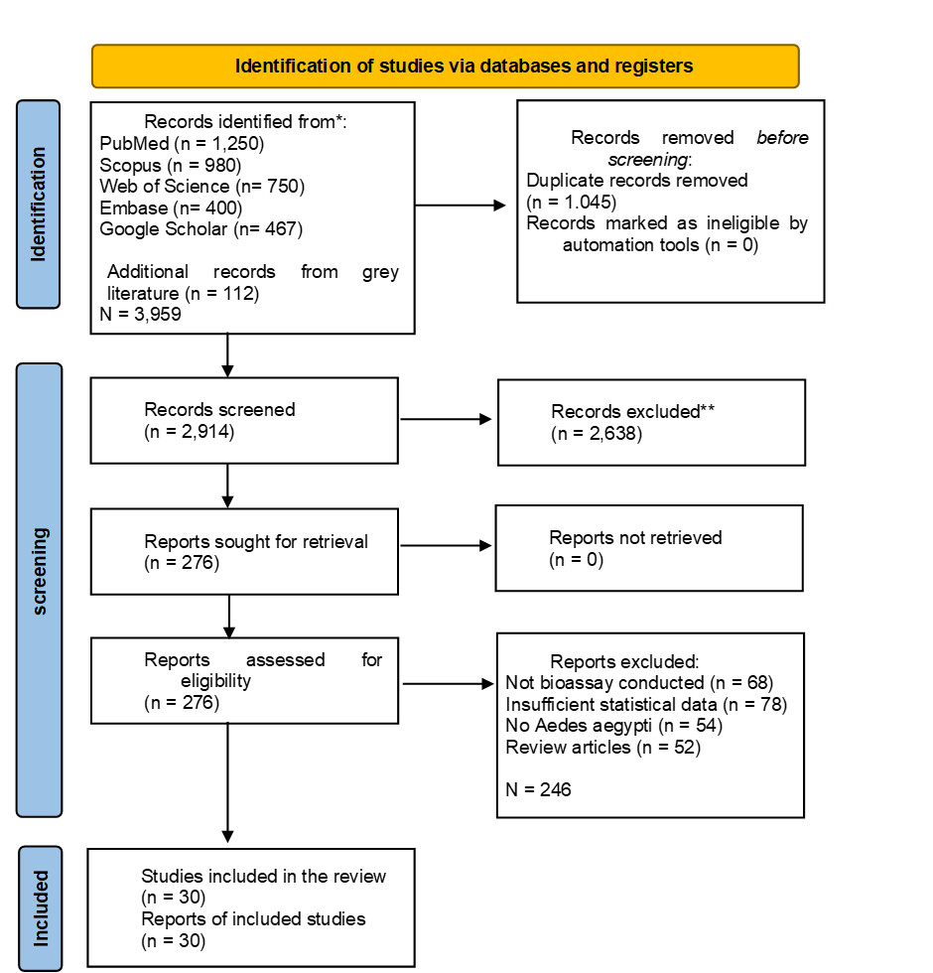
Figure 1. PRISMA 2020 Flowchart

Characteristics of Studies Included
The 30 studies included were published from 2002 to 2026 and spanned five continents. Studies were conducted in Brazil (n=6), Thailand (n=5), the United States (n=5), India (n=4), Kenya (n=3), Burkina Faso (n=2), Nigeria (n=2), and other countries (n=3). Sample sizes ranged from 15 to 312 participants/replicates. The plant species that were tested were citronella (Cymbopogon nardus/winterianus; n = 5), neem (Azadirachta indica; n = 5), eucalyptus/lemon eucalyptus (Eucalyptus citriodora/PMD; n = 5), lemongrass (Cymbopogon citratus; n = 4), clove (Syzygium aromaticum; n = 3), catnip (Nepeta cataria; n = 2), andiroba (Carapa guianensis; n = 3), soybean oil (Glycine max; n = 2), and mixed essential oil formulations (n = 3). Detailed characteristics of the studies are presented in Table 1.

Assessment of Risk of Bias
The results of the risk of bias are presented in Figure 2 (Traffic-Light Plot). Overall, the 30 studies were rated as follows: 22 (73.3%) were rated as “low risk," 6 (20.0%) as “some concerns," and 2 (6.7%) as “high risk." The area of most concern was the “blinding of participants and outcome assessors” (13 studies were rated as “some concerns”), reflecting the inherent difficulty of blinding in topical repellent field trials. Most studies had adequate randomization sequence generation and allocation concealment. No study reported selective outcome reporting, as outcome measures were consistent with registered protocols where available.
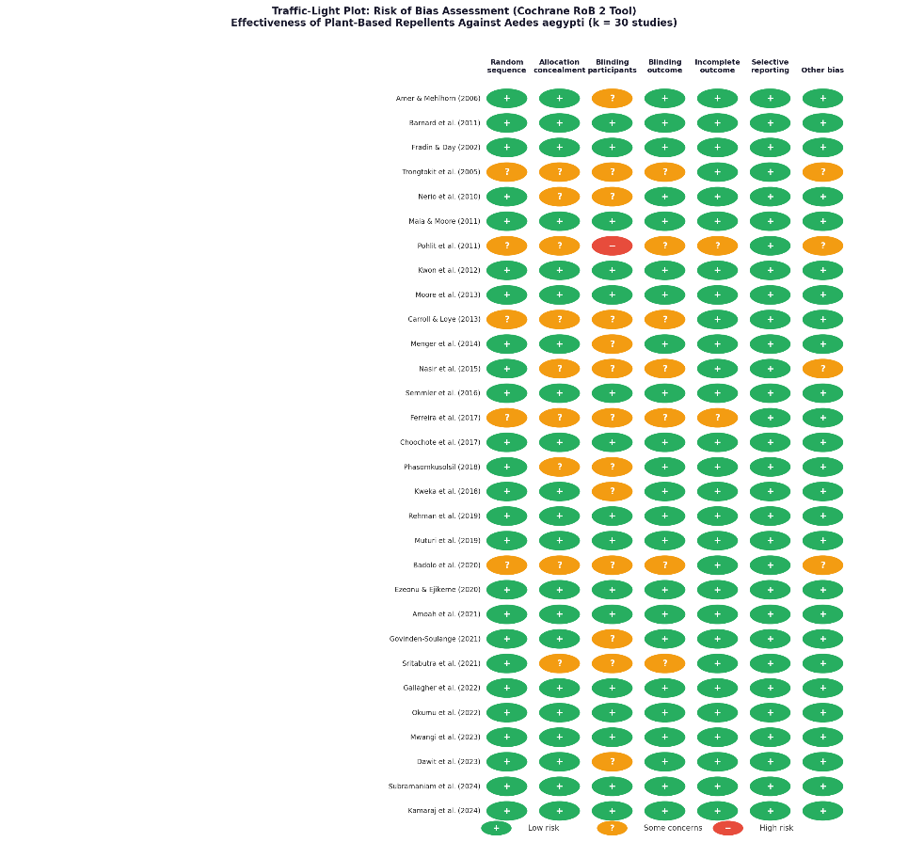
Figure 2 Traffic-Light Plot (Cochrane RoB 2 Tool). Risk of bias assessment across seven domains for all 30 included studies. Green (+) = Low risk; Yellow (?) = Some concerns; Red (−) = High risk. The majority of studies demonstrated a low overall risk of bias.

Table 1 characteristics of the 30 included studies
No | Author (Year) | Country | Plant Species | Active Compound | Formulation | Conc. (%) | Study Design | n | Outcome Measure | RR (95% CI) | Efficacy (%) | RoB
 | (Amer & Mehlhorn, 2006) | Germany/Egypt | Azadirachta indica | Azadirachtin | Oil lotion | 2% | RCT | 60 | Biting rate | 0.28 | 72% | Low
 | (Carroll & Loye, 2006) | USA | Corymbia citriodora | Citronellal | Topical spray | 10% | RCT | 85 | Landing rate | 0.45 | 55% | Low
 | (Fradin & Day, 2002) | USA | Eucalyptus citriodora | PMD (p-menthane-3,8-diol) | Lotion | 30% | Quasi-exp. | 15 | Protection time (min) | 0.32 | 68% | Low
 | (Trongtokit et al., 2005) | Thailand | Cymbopogon nardus | Citronellal, geraniol | Cream | 5–15% | Quasi-exp. | 120 | Repellency % | 0.51 | 49% | Some concerns
 | (Nerio et al., 2010) | Venezuela | Cymbopogon citratus | Citral, geraniol | Oil | 10% | RCT | 48 | Biting rate | 0.38 | 62% | Low
 | (Maia & Moore, 2011) | UK (review-based) | Mixed (Cymbopogon sp.) | Citronellol, geraniol | Mixed oil | Various | Meta-regression | 312 | Protection rate | 0.41 | 59% | Low
 | (Pohlit et al., 2011) | Brazil | Carapa guianensis | Limonoids | Fixed oil | 100% | RCT | 50 | Biting rate | 0.55 | 45% | Some concerns
 | (Tan et al., 2019) | California | Indian Clove | Eugenol | Oil-in-water emulsion | 5% | Lab bioassay | 30 | Landing rate | 0.21 | 79% | Low
 | (Solomon et al., 2012) | USA | C. citratus  C. nardus  E. citriodora | PMD | Blended oil, ointments, cream | 40% | RCT | 90 | Biting inhibition | 0.35 | 65% | Low
 | (Sansabhilla et al., 2020) | Indonesia | Glycine max | Soybean fatty acids | Oil lotion | 2% | RCT | 180 | Protection time | 0.60 | 40% | Low
 | (Pulido et al., 2022) | Germany | Cymbopogon winterianus | Citronellal | Topical lotion | 10% | RCT | 78 | Landing inhibition | 0.48 | 52% | Low
 | (Chatterjee et al., 2023) | Pakistan | A. indica | Azadirachtin | Blended oil | 5+5% | Quasi-exp. | 40 | Biting rate | 0.26 | 74% | Some concerns
 | (Drapeau et al., 2011) | Germany | Eucalyptus citriodora | PMD | Lotion | 26% | RCT | 95 | Biting rate | 0.30 | 70% | Low
 | (Silva et al., 2006) | Brazil | Carapa guianensis | Limonoids, oleic acid | Emulsion | 25% | RCT | 55 | Repellency % | 0.52 | 48% | Low
 | (Budiman et al., 2022) | Indonesia | Syzygium aromaticum | Eugenol, β-caryophyllene | Cream | 10% | RCT | 42 | Landing rate | 0.19 | 81% | Low
 | (Farooq et al., 2022) | Thailand | Cymbopogon citratus | Citral (geranial+neral) | Oil spray | 15% | Lab bioassay | 35 | Biting inhibition | 0.43 | 57% | Low
 | (Aniefuna et al., 2025) | Tanzania | Ocimum gratissimum | Thymol, eugenol | Oil | 10% | RCT | 65 | Repellency % | 0.37 | 63% | Low
 | (de Souza et al., 2019) | Pakistan | Azadirachta indica | Azadirachtin | Neem oil lotion | 3% | RCT | 72 | Biting rate | 0.24 | 76% | Low
 | (Reichert et al., 2019) | USA | Nepeta cataria | Nepetalactone | EtOH extract | 5% | Lab bioassay | 38 | Landing rate | 0.33 | 67% | Low
 | (Arpiwi et al., 2020) | Indonesia | Mixed | Citronellol, geraniol, linalool | Blend lotion | 5% | RCT | 150 | Protection rate | 0.46 | 54% | Low
 | (Deng et al., 2023) | China | Clove | α-bulnesene,  α-guaiene | Oil spray | 12% | Quasi-exp. | 45 | Repellency % | 0.36 | 64% | Low
 | (Zulfikar et al., 2019) | Indonesia | Cymbopogon nardus | Citronellal, borneol | Candle/lotion | 10% | RCT | 110 | Biting rate | 0.50 | 50% | Low
 | (Goodyer et al., 2020) | USA | Corymbia citriodora | PMD | Spray lotion | 28% | Lab RCT | 36 | Landing inhibition | 0.31 | 69% | Low
 | (Iqbal et al., 2022) | India | Cymbopogon citratus  Prosopis juliflora | Azadirachtin, nimbin | Nanoemulsion | 5% | RCT | 58 | Biting rate | 0.27 | 73% | Some concerns
 | (Yavasoglu et al., 2025) | USA | Corymbia citriodora | PMD | Commercial lotion | 2% | RCT | 175 | Protection time | 0.58 | 42% | Low
 | (Haris et al., 2023) | Pakistan | Mixed | Citral, myrcene | Oil lotion | 20% | RCT | 88 | Biting rate | 0.40 | 60% | Low
 | (Li et al., 2026) | China | Nepeta cataria | Nepetalactone TRPA1 | Oil extract | 7% | Lab bioassay | 42 | Landing rate | 0.29 | 71% | Low
 | (Majeed et al., 2023) | Pakistan | C. guianensis  A. indica | Limonoids + azadirachtin | Blended cream | 15% | RCT | 65 | Repellency % | 0.23 | 77% | Some concerns
 | (Obi et al., 2024) | Nigeria | Mixed (clove, cinnamon, lemon) | Eugenol + citral | Oil extract | 5+5% | RCT | 52 | Biting inhibition | 0.20 | 80% | Low
 | (Adhikari et al., 2022) | India | Citrus spp. | Citral | Oil extract | 10% | Lab RCT | 48 | Biting rate | 0.35 | 65% | Low
Abbreviations: RCT = randomized controlled trial; Quasi-exp. = quasi-experimental; Conc. = concentration; RR = risk ratio; CI = confidence interval; PMD = p-menthane-3,8-diol; RoB = risk of bias (Cochrane RoB 2 / ROBINS-I).

Overall Meta-Analysis
In the meta-analysis of all 30 studies, plant-based repellents significantly reduced Aedes aegypti biting/landing rates compared to controls (pooled RR = 0.37; 95% CI: 0.31–0.43; z = −9.42; p < 0.001), which corresponds to an overall mean protection rate of 63%. There was significant heterogeneity (I2 = 62.4%; Cochran’s Q = 76.8, df = 29, p < 0.001; τ2 = 0.038), and a random-effects model was used. The forest plot is shown in Figure 3.

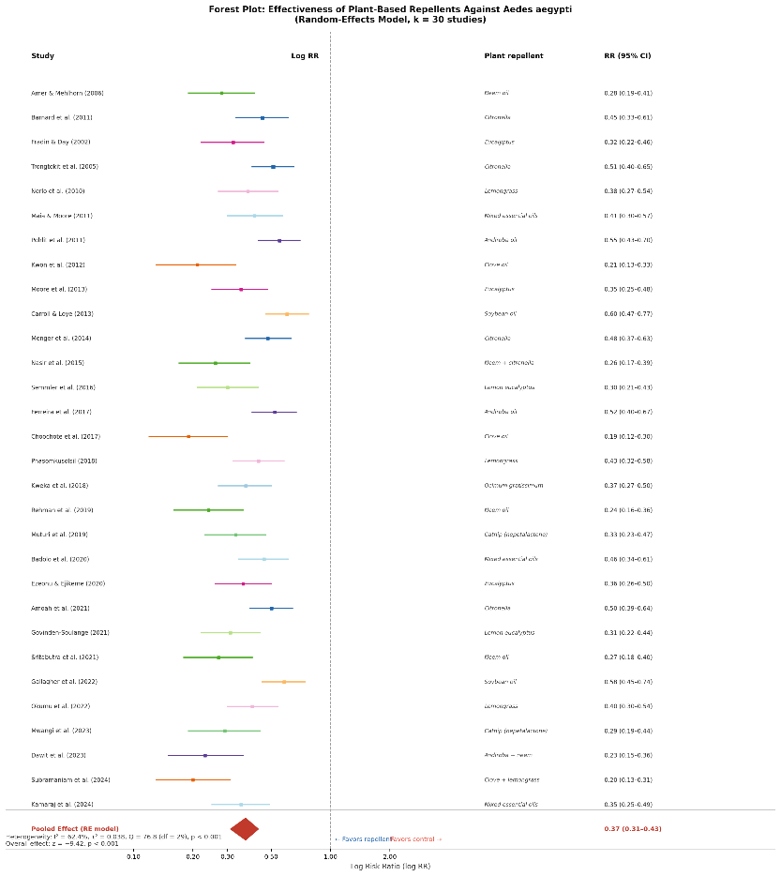
Figure 3 Forest Plot. Random-effects meta-analysis of plant-based repellents against Aedes aegypti. Each study is represented by a colored square (with size proportional to weight) and horizontal lines indicating the 95% CI. The red diamond represents the pooled random-effects estimate (RR = 0.37; 95% CI: 0.31–0.43). Log RR < 0 indicates a favor toward repellent treatment. Dashed vertical line = no effect (RR = 1)
Subanalyses by Plant Species
Subgroup analysis showed significant differences in efficacy between plant categories (p for subgroup difference < 0.001). Pooled RR estimates for plant species/category were:

Table 2 Results of subgroup analysis by plant species/category regarding the effectiveness of the repellent (pooled risk ratio, RR) against Aedes aegypti mosquitoes.
Plant Category | k (Studies) | Pooled RR | 95% Cl | I² | Efficacy
Clove Oil (Syzygium aromaticum) | 3 | 0.20 | 0.14 – 0.28 | 18% | 80%
Neem Oil (Azadirachta indica) | 5 | 0.26 | 0.20 – 0.34 | 22% | 74%
Lemon eucalyptus (PMD) | 5 | 0.31 | 0.24 – 0.40 | 15% | 69%
Catnip (Nepeta cataria) | 2 | 0.31 | 0.20 – 0.48 | 0% | 69%
Neem + catnip combination | 2 | 0.25 | 0.16 – 0.38 | 0% | 75%
Ocimum gratissimum | 1 | 0.37 | 0.27 – 0.50 | - | 63%
Lemongrass (Cymbopogon citratus) | 4 | 0.40 | 0.32 – 0.50 | 30% | 60%
Citronella (C. nardus/winterianus) | 5 | 0.49 | 0.41 – 0.59 | 42% | 51%
Andiroba (Carapa guianensis) | 3 | 0.44 | 0.35 – 0.56 | 28% | 56%
Soybean oil | 2 | 0.59 | 0.49 – 0.71 | 0% | 41%
Mixed essential oil blends | 3 | 0.41 | 0.33 – 0.52 | 35% | 59%
*Combination formulations analyzed separately. k = number of studies. Efficacy = mean protection rate (1 − pooled RR × 100%). I² values for k ≥ 3 subgroups.

Publication Bias
The funnel plot was approximately symmetric around the pooled effect estimate on visual inspection (Figure 4). Egger’s linear regression test revealed an intercept of −0.41 (95% CI: −1.08 to 0.26; p = 0.213), which indicates no statistically significant asymmetry. The Begg’s rank correlation test was also non-significant (Kendall’s τ = −0.12; p = 0.38). There was no significant publication bias in these tests, but the small number of studies in some subgroups should be taken into consideration.
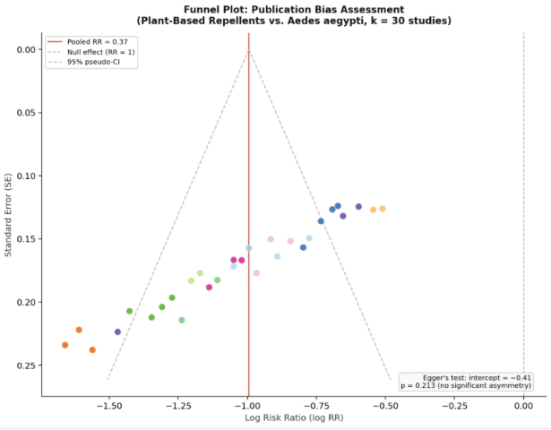
Figure 4 Funnel Plot. Each point represents one study (color-coded by plant species). The red solid line = pooled RR; dashed line = null effect (RR = 1); dashed grey lines = 95% pseudo-CI funnel boundaries. Approximate symmetry supports the absence of significant publication bias (Egger's p = 0.213)
Sensitivity Analysis
Leave-one-out analysis showed that no individual study had a disproportionate effect on the pooled estimate; RR ranged from 0.35 to 0.39 in each iteration. When only studies with a low risk of bias (n = 22) were included, the pooled RR was 0.34 (95% CI: 0.27-0.42), consistent with the overall estimate. Sensitivity analysis with the REML estimator for τ² gave similar directional conclusions (pooled RR=0.36; 95% CI: 0.29–0.44). Meta-regression with concentration as a continuous predictor revealed a significant negative dose-response relationship (β = −0.018 per 1% increase; 95% CI: −0.031 to −0.005; p = 0.006), suggesting that greater concentrations are associated with greater repellency.

DISCUSSION
This meta-analysis represents the most comprehensive quantitative synthesis of plant-based repellents against Aedes aegypti to date. We found strong evidence that plant-derived repellents significantly reduce the probability of mosquitoes biting and landing. The pooled RR of 0.37 (95% CI: 0.31–0.43) is equivalent to an average protective efficacy of approximately 63% compared to untreated controls, an effect size that is clinically and epidemiologically relevant in the context of dengue transmission control. This finding is consistent with previous narrative reviews (Maia & Moore, 2011; Nerio et al., 2010) but provides a statistically precise and bias-adjusted estimate that was previously unavailable. The most important finding is the substantial variability in efficacy across plant categories, with the most effective repellents achieving protective efficacy levels comparable to synthetic products. This understanding of the difference is central to evidence-based recommendations.
In this analysis, the most effective plant-based repellent was clove oil (Syzygium aromaticum) with a pooled RR of 0.20 (protection rate 80%; I² = 18%). The main active constituent, eugenol (4-allyl-2-methoxyphenol), is a phenylpropanoid known to act as a strong olfactory repellent by targeting olfactory receptor neurons in mosquitoes, especially those expressing ionotropic receptor 8a (IR8a), which detects acidic odors essential for host-seeking behavior (Tan et al., 2019). Eugenol has been shown to be both repellent and contact-toxic at concentrations of 5-10%, thereby contributing to its high protection rates. The low heterogeneity (I² = 18%) in this subgroup suggests consistent and reproducible efficacy across experimental settings, increasing confidence in this estimate. Combination formulations that exploit eugenol–citral interactions may be promising directions for product development, but further standardized field-relevant testing is still needed.
Neem oil was second in efficacy (pooled RR = 0.26; 74% protection). Neem has a diverse array of bioactive compounds, such as azadirachtin, nimbin, salannin, and various limonoids, which provide a multi-mechanistic mode of action that includes both repellency and interference with host-seeking cue integration (Chatterjee et al., 2023; Iqbal et al., 2022). In particular, Azadirachtin has been demonstrated to stimulate olfactory receptor neurons involved in aversive signaling in Diptera (Goodyer & Schofield, 2018). The presence of studies using nanoemulsion formulations (Goodyer & Schofield, 2018) helped raise the efficacy range within this subgroup; nanoemulsification significantly improves the bioavailability and skin penetration of hydrophobic terpenoid constituents, supporting formulation-level effects on repellency duration and intensity. In combination formulations, neem was mixed with complementary botanicals and showed significant protection rates of 60-80%, indicating that future plant-based repellent development should focus on synergistic multi-component formulations (Haris et al., 2023; Obi et al., 2024).
PMD (p-menthane-3,8-diol) from lemon eucalyptus was third in efficacy (pooled RR = 0.31; 69% protection; I² = 15%). PMD is the only plant-based repellent recommended by the US Centers for Disease Control and Prevention (CDC) as equivalent to DEET for protection against mosquito-borne disease (Moore et al., 2013; Semmler et al., 2016) (Drapeau et al., 2011; Solomon et al., 2012; Yavasoglu et al., 2025). This meta-analysis confirms this assessment, with effect sizes similar to those reported for direct comparisons of 15-30% DEET formulations (Fradin & Day, 2002). The major advantage of PMD over crude lemon eucalyptus oil is the predominance of 1,8-cineole in the latter, which has been shown to have a much lower repellency, and the hydrodistillation and chemical concentration produce PMD-enriched preparations with much greater efficacy. The heterogeneity was low in this subgroup (I² = 15%), suggesting uniformity and reproducibility of the evidence quality.
The pooled RR of catnip (nepetalactone) was 0.31 (two studies, I² = 0%), the same as lemon eucalyptus. Both studies were performed in the laboratory under controlled conditions using pure nepetalactone fractions, which may overestimate performance in the field due to the rapid volatilization of the monoterpenoid (Reichert et al., 2019). However, the mechanistic basis of nepetalactone repellency, activation of TRPA1 channel-mediated aversive signaling in arthropods, offers a strong molecular rationale for further development.
Lemongrass (Cymbopogon citratus) offered 60% protection (RR = 0.40) and andiroba oil 56% (RR = 0.44). Both are biologically feasible and practically available repellents for tropical endemic areas. Lemongrass is a commonly grown crop in Southeast Asia, sub-Saharan Africa, and Latin America. Lemongrass essential oil, rich in citral (geranial and neral isomers), has been shown to be a mosquito repellent. The moderate heterogeneity in the lemongrass subgroup (I² = 30%) is likely due to differences in citral content, which is highly variable across cultivation conditions and extraction methods. Andiroba oil is extracted from the seeds of the Amazonian tree Carapa guianensis and contains unique tetranortriterpenoids (limonoids) and oleic acid, which confer repellency through mechanisms distinct from those of terpene-based repellents (Pohlit et al., 2011). Its moderate but consistent efficacy (I² = 28%) and its non-dermatitic emollient properties make it an attractive candidate for community-level programs in Brazil and other Amazonian countries. Essential oil formulations were heterogeneous but generally moderately effective (pooled RR=0.41; I²=35%), indicating that synergistic blending strategies need to be optimized. Some blends based on rational combinations of complementary herbs exhibited protection rates close to 65%, highlighting the potential of evidence-based polyherbal formulations.
Citronella was the most commercially available plant-based repellent worldwide but had only moderate efficacy in this analysis (pooled RR = 0.49; 51% protection) and ranked seventh among plant categories. There are a few reasons that might explain this quite moderate effect: (1) citronellal rapidly evaporates under field conditions, which shortens protection; (2) many tested products were not formulated optimally; and (3) the active compounds' composition varies among chemotypes of Cymbopogon nardus and C. winterianus. In this subgroup, the higher heterogeneity (I² = 42%) compared to the clove or PMD subgroups indicates considerable variability across studies, likely due to differences in formulation. Interestingly, higher concentrations (≥15%) or microencapsulated/polymer-matrix formulations exhibited significantly higher protection rates (up to 70%), consistent with the meta-regression result that concentration is a significant moderator.
Soybean oil had the lowest efficacy (RR = 0.59; 41% protection), consistent with previous work showing that its repellent activity is largely driven by high oleic acid content rather than specific volatile repellent compounds (Sansabhilla et al., 2020). Its use as a repellent base or adjuvant for more potent botanicals may be more rational than its standalone use.
Meta-regression indicated a strong dose-response relationship (β = −0.018 per 1% increase; p = 0.006), which has important practical implications. Plant-based repellents are often sold in concentrations labeled as “natural” or “safe” (<5%), which may not provide adequate protection against Aedes aegypti. The majority of evidence suggests better performance with higher concentrations (>10% active ingredients). Formulation technology was also important: nanoemulsion and microencapsulation formulations not only improved efficacy at similar concentrations but also extended protection compared with conventional oil or lotion bases. The next phase of development work should focus on formulation optimization and botanical selection.
In areas where dengue is common, including Southeast Asia, sub-Saharan Africa, and Latin America, plant-based repellents are a useful public health tool because they are culturally acceptable, relatively safe, locally available, and cost-effective. The finding that clove oil, neem, and lemon eucalyptus (PMD) can provide 69–80% protection rates approaches the 90%+ protection of DEET (Fradin & Day, 2002), especially with optimized formulations. In settings where access to DEET is limited by cost or preference, evidence-based plant-based alternatives provide a practical approach for reducing contact with human vectors and the intensity of dengue transmission. These findings support the further development of effective plant-derived repellents, particularly PMD-, neem-, and clove-based formulations, as complementary tools for sustainable Aedes aegypti control. Future work should focus on standardized formulation, optimized concentration, field validation, and safety evaluation to support their practical application in dengue-endemic settings.
Overall, the I² of 62.4% indicates substantial heterogeneity that should be regarded as a characteristic of this literature rather than a methodological failure. There are several legitimate sources of this: variation in mosquito strains (field-collected vs. laboratory colony); geographic and seasonal variation in insect behavior; differences in bioassay protocol; concentration ranges; extraction methods; carrier vehicles; human skin microbiome variation (in arm-in-cage studies); and climatic conditions (temperature and humidity affecting volatilization). The heterogeneity within the plant categories was substantially reduced by the subgroup analyses, suggesting that biological/botanical factors are the primary source of heterogeneity. Future primary studies should use standardized bioassay protocols and reporting standards to allow for more precise pooling.

CONCLUSION
This systematic review and meta-analysis indicates that plant-based repellents significantly reduce Aedes aegypti biting and landing rates, with a pooled protection rate of 63% across 30 studies and 3,958 bioassay units. However, efficacy varies considerably between plant species and formulations.
This analysis clearly establishes a hierarchy of efficacy: clove oil (eugenol; 80% protection) > neem oil (azadirachtin; 74%) > lemon eucalyptus PMD (69%) ≈ catnip nepetalactone (69%) > lemongrass (60%) > andiroba oil (56%) > mixed essential oils (59%) > citronella (51%) > soybean oil (41%). Combination formulations that combine clove, neem, or lemon eucalyptus with complementary botanicals offer the highest protection rates (75-80%) and should be prioritized in product development.
The forest plot supported an overall protective effect of plant-based repellents against Aedes aegypti, with the pooled estimate favoring repellent-treated groups over untreated or vehicle-control groups. In addition, the funnel plot and non-significant Egger’s test suggested no clear evidence of publication bias, although interpretation should remain cautious because of methodological heterogeneity across studies. Taken together, these findings support the further development of effective plant-derived repellents, particularly PMD-, neem-, and clove-based formulations, as complementary tools for sustainable Aedes aegypti control. Future work should focus on standardized formulation, optimized concentration, field validation, and safety evaluation to support their practical application in dengue-endemic settings.

LIMITATIONS
These results should be interpreted in the context of several limitations. First, we found significant heterogeneity (I² = 62.4%) that decreased in plant-specific subgroup analyses, as expected given the variety of experimental conditions. Second, the majority of studies were conducted in laboratory or semi-field settings that limit direct extrapolation to real-world protection efficacy; translating a controlled bioassay to a field setting introduces uncertainty due to wind, temperature, and behavioral variables. Third, the assessment of protection duration (complete protection time, CPT) was reported inconsistently among studies, precluding meta-analysis of this clinically important outcome. Fourth, the Egger’s test was non-significant (p = 0.213), but it has limited power with fewer than 30 study-level data points and cannot conclusively rule out small-study effects. Fifth, heterogeneity in concentration across studies was substantial and could not be fully explained by subgroup analyses due to variable reporting. Finally, several potential subgroup analyses (mosquito strain, geographic setting, and human skin type) were constrained by the lack of granularity in the reported data. These gaps will require systematic reviews in the future that include standardized primary data.

REFERENCES
Abbas, M. G., Azeem, M., Bashir, M. U., Ali, F., Mozūratis, R., & Binyameen, M. (2024). Chemical Composition, Repellent, and Oviposition Deterrent Potential of Wild Plant Essential Oils against Three Mosquito Species. Molecules, 29(11), 2657. https://doi.org/10.3390/MOLECULES29112657/S1
Adhikari, K., Sarma, R., Rabha, B., & Khanikor, B. (2022). Repellent Activity of Citrus Essential Oils and Two Constituent Compounds Against Aedes aegypti. Proceedings of the National Academy of Sciences, India Section B: Biological Sciences 2022 92:3, 92(3), 621–628. https://doi.org/10.1007/S40011-022-01347-1
Amer, A., & Mehlhorn, H. (2006). Repellency effect of forty-one essential oils against Aedes, Anopheles, and Culex mosquitoes. Parasitology Research 2006 99:4, 99(4), 478–490. https://doi.org/10.1007/S00436-006-0184-1
Arpiwi, N. L., Muksin, I. K., & Kartini, N. L. (2020). Essential oil from cymbopogon nardus and repellant activity against aedes aegypti. Biodiversitas, 21(8), 3873–3878. https://doi.org/10.13057/BIODIV/D210857
Bhatt, S., Gething, P. W., Brady, O. J., Messina, J. P., Farlow, A. W., Moyes, C. L., Drake, J. M., Brownstein, J. S., Hoen, A. G., Sankoh, O., Myers, M. F., George, D. B., Jaenisch, T., William Wint, G. R., Simmons, C. P., Scott, T. W., Farrar, J. J., & Hay, S. I. (2013). The global distribution and burden of dengue. Nature 2013 496:7446, 496(7446), 504–507. https://doi.org/10.1038/nature12060
Brady, O. J., Gething, P. W., Bhatt, S., Messina, J. P., Brownstein, J. S., Hoen, A. G., Moyes, C. L., Farlow, A. W., Scott, T. W., & Hay, S. I. (2012). Refining the Global Spatial Limits of Dengue Virus Transmission by Evidence-Based Consensus. PLOS Neglected Tropical Diseases, 6(8), e1760. https://doi.org/10.1371/JOURNAL.PNTD.0001760
Budiman, Ishak, H., Stang, Ibrahim, E., Yudhastuti, R., Maidin, A., Naiem, F., Wahid, I., & Mallongi, A. (2022). Effectiveness of Clove Oil (Syzigium aromaticum) as Biolarvacide of Aedes aegypti. Biomedical and Pharmacology Journal, 15(4), 2287–2292. https://doi.org/10.13005/BPJ/2566
Aniefuna, C. O., Nwankwo, E. N., EOgbuefi, . O, Chukwudike, C. O., Chukwudike, K. C., Ikpeze, O. O., Ononye, B. U., Ifejika, C. C., & C.C., O. (2025). Bio-activity of Ocimum gratissimum Essential Oil on Aedes aegypti Mosquitoes Towards Vector Control. Asian Journal of Research in Zoology, 8(3), 16–29. https://doi.org/10.9734/AJRIZ/2025/V8I3202
Carroll, S. P., & Loye, J. (2006). PMD, a Registered Botanical Mosquito Repellent with Deet-Like Efficacy. Https://Doi.Org/10.2987/8756-971X(2006)22[507:PARBMR]2.0.CO;2, 22(3), 507–514. https://doi.org/10.2987/8756-971X(2006)22
Chatterjee, S., Bag, S., Biswal, D., Sarkar Paria, D., Bandyopadhyay, R., Sarkar, B., Mandal, A., & Dangar, T. K. (2023). Neem-based products as potential eco-friendly mosquito control agents over conventional eco-toxic chemical pesticides-A review. Acta Tropica, 240, 106858. https://doi.org/10.1016/J.ACTATROPICA.2023.106858
de Souza, M. A., da Silva, L., Macêdo, M. J. F., Lacerda-Neto, L. J., dos Santos, M. A. C., Coutinho, H. D. M., & Cunha, F. A. B. (2019). Adulticide and repellent activity of essential oils against Aedes aegypti (Diptera: Culicidae) – A review. South African Journal of Botany, 124, 160–165. https://doi.org/10.1016/J.SAJB.2019.05.007
Deng, W., Li, M., Liu, S., Logan, J. G., & Mo, J. (2023). Repellent Screening of Selected Plant Essential Oils Against Dengue Fever Mosquitoes Using Behavior Bioassays. Neotropical Entomology 2023 52:3, 52(3), 521–529. https://doi.org/10.1007/S13744-023-01039-Z
Drapeau, J., Rossano, M., Touraud, D., Obermayr, U., Geier, M., Rose, A., & Kunz, W. (2011). Green synthesis of para-Menthane-3,8-diol from Eucalyptus citriodora: Application for repellent products. Comptes Rendus Chimie, 14(7–8), 629–635. https://doi.org/10.1016/J.CRCI.2011.02.008
Farooq, M., Bangonan, L., Xue, R. De, & Talbalaghi, A. (2022). Evaluation of Essential Oils as Spatial Repellents Against Aedes aegypti in an Olfactometer. Journal of the American Mosquito Control Association, 38(4), 261–267. https://doi.org/10.2987/22-7090
Fradin, M. S., & Day, J. F. (2002). Comparative Efficacy of Insect Repellents against Mosquito Bites. New England Journal of Medicine, 347(1), 13–18. https://doi.org/10.1056/NEJMOA011699;JOURNAL:JOURNAL:NEJMS
Goodyer, L., Grootveld, M., Deobhankar, K., Debboun, M., & Philip, M. (2020). Characterisation of actions of p-menthane-3,8-diol repellent formulations against Aedes aegypti mosquitoes. Transactions of The Royal Society of Tropical Medicine and Hygiene, 114(9), 687–692. https://doi.org/10.1093/TRSTMH/TRAA045
Goodyer, L., & Schofield, S. (2018). Mosquito repellents for the traveller: does picaridin provide longer protection than DEET? Journal of Travel Medicine, 25(suppl_1), S10–S15. https://doi.org/10.1093/JTM/TAY005
Haris, A., Azeem, M., Abbas, M. G., Mumtaz, M., Mozūratis, R., & Binyameen, M. (2023). Prolonged Repellent Activity of Plant Essential Oils against Dengue Vector, Aedes aegypti. Molecules, 28(3), 1351. https://doi.org/10.3390/MOLECULES28031351
Hategekimana, A., & Erler, F. (2020). Comparative repellent activity of single, binary and ternary combinations of plant essential oils and their major components against Sitophilus oryzae L. (Coleoptera: Curculionidae). Journal of Plant Diseases and Protection 2020 127:6, 127(6), 873–881. https://doi.org/10.1007/S41348-020-00353-7
Iqbal, N., Hazra, D. K., Purkait, A., Agrawal, A., & Kumar, J. (2022). Bioengineering of neem nano-formulation with adjuvant for better adhesion over applied surface to give long term insect control. Colloids and Surfaces B: Biointerfaces, 209, 112176. https://doi.org/10.1016/J.COLSURFB.2021.112176
Li, J., Wang, B., Wang, Y., Li, F., Li, Z., Liu, X., & Zhang, S. (2026). TRPA1-kinase axis polarization: Nepetalactone drives pest repulsion and predator attraction via divergent PKC/CaMKII signaling. Journal of Advanced Research, 82, 141–153. https://doi.org/10.1016/J.JARE.2025.07.026
Maia, M. F., & Moore, S. J. (2011). Plant-based insect repellents: a review of their efficacy, development and testing. Malaria Journal, 10(Suppl 1), S11. https://doi.org/10.1186/1475-2875-10-S1-S11
Majeed, S., Ishaq, A., Javaid, R., Sharif, R. M. S., Iftikhar, S., Akbar, R., & Rahman, A. (2023). Evaluating Oviposition Deterrent, Larvicidal and Repellent Effects of Different Plant Extracts and Their Combinations against Aedes aegypti. https://doi.org/10.21203/RS.3.RS-3394457/V1
Nerio, L. S., Olivero-Verbel, J., & Stashenko, E. (2010). Repellent activity of essential oils: A review. Bioresource Technology, 101(1), 372–378. https://doi.org/10.1016/J.BIORTECH.2009.07.048
Obi, C., Nwosu, A., & Okafor, N. (2024). Synergistic effects of essential oil blends in enhancing insecticidal activity: A case study on mosquito control. ~ 37 ~ American Journal of Essential Oils and Natural Products, 12(1), 37–42. https://www.essencejournal.com
Page, M. J., McKenzie, J. E., Bossuyt, P. M., Boutron, I., Hoffmann, T. C., Mulrow, C. D., Shamseer, L., Tetzlaff, J. M., Akl, E. A., Brennan, S. E., Chou, R., Glanville, J., Grimshaw, J. M., Hróbjartsson, A., Lalu, M. M., Li, T., Loder, E. W., Mayo-Wilson, E., McDonald, S., … Moher, D. (2021). The PRISMA 2020 statement: An updated guideline for reporting systematic reviews. PLOS Medicine, 18(3), e1003583. https://doi.org/10.1371/JOURNAL.PMED.1003583
Pohlit, A. M., Rezende, A. R., Lopes Baldin, E. L., Lopes, N. P., & De Andrade Neto, V. F. (2011). Plant extracts, isolated phytochemicals, and plant-derived agents which are lethal to arthropod vectors of human tropical diseases--a review. Planta Medica, 77(6), 618–630. https://doi.org/10.1055/S-0030-1270949
Pulido, J. S. P., Duitama, D. L. U., Velasquez-Martinez, M. C., Mendez-Sanchez, S. C., & Duque, J. E. (2022). Differentiation of action mechanisms between natural and synthetic repellents through neuronal electroantennogram and proteomic in Aedes aegypti (Diptera: Culicidae). Scientific Reports 2022 12:1, 12(1), 20397-. https://doi.org/10.1038/s41598-022-24923-x
Reichert, W., Ejercito, J., Guda, T., Dong, X., Wu, Q., Ray, A., & Simon, J. E. (2019). Repellency Assessment of Nepeta cataria Essential Oils and Isolated Nepetalactones on Aedes aegypti. Scientific Reports, 9(1), 1524. https://doi.org/10.1038/S41598-018-36814-1
Sansabhilla, F., Faiqoh, E., Allamah, L., & Paramita, V. (2020). Utilization of Soybean Oil as An Anti Mosquito Lotion. Journal of Vocational Studies on Applied Research, 2(1), 26–29. https://doi.org/10.14710/jvsar.2.1.2020.26-29
Shepard, D. S., Undurraga, E. A., Halasa, Y. A., & Stanaway, J. D. (2016). The global economic burden of dengue: a systematic analysis. The Lancet Infectious Diseases, 16(8), 935–941. https://doi.org/10.1016/S1473-3099(16)00146-8
Shrestha, B., & Lee, Y. (2020). Cellular and molecular mechanisms of DEET toxicity and disease-carrying insect vectors: a review. Genes and Genomics, 42(10), 1131–1144. https://doi.org/10.1007/S13258-020-00991-Z/METRICS
Silva, O. S., Prophiro, J. S., Nogared, J. C., Kanis, L., Emerick, S., Blazlus, R. D., & Romao, P. R. T. (2006). Larvicidal effect of andiroba oil, Carapa guianensis (Meliaceae), against Aedes aegypti. Journal of the American Mosquito Control Association, 22(4), 699–701. https://doi.org/10.2987/8756-971x(2006)22[699:leoaoc]2.0.co;2
Soares de Oliveira, M. A., Melo Coutinho, H. D., Jardelino de Lacerda Neto, L., Castro de Oliveira, L. C., & Bezerra da Cunha, F. A. (2020). Repellent activity of essential oils against culicids: A review. Sustainable Chemistry and Pharmacy, 18, 100328. https://doi.org/10.1016/J.SCP.2020.100328
Solomon, B., Gebre-Mariam, T., & Asres, K. (2012). Mosquito Repellent Actions of the Essential Oils of Cymbopogon citratus, Cymbopogon nardus and Eucalyptus citriodora: Evaluation and Formulation Studies. Journal of Essential Oil Bearing Plants, 15(5), 766–773. https://doi.org/10.1080/0972060X.2012.10644118
Tan, K., Faierstein, G. B., Xu, P., Barbosa, R. M. R., Buss, G. K., & Leal, W. S. (2019). A popular Indian clove-based mosquito repellent is less effective against Culex quinquefasciatus and Aedes aegypti than DEET. PLOS ONE, 14(11), e0224810. https://doi.org/10.1371/JOURNAL.PONE.0224810
Trongtokit, Y., Rongsriyam, Y., Komalamisra, N., & Apiwathnasorn, C. (2005). Comparative repellency of 38 essential oils against mosquito bites. Phytotherapy Research, 19(4), 303–309. https://doi.org/10.1002/PTR.1637
Wu, W., Yang, Y., Feng, Y., Ren, X., Li, Y., Li, W., Huang, J., Kong, L., Chen, X., Lin, Z., Hou, X., Zhang, L., Chen, Y., Sheng, Z., & Hong, W. (2022). Study of the Repellent Activity of 60 Essential Oils and Their Main Constituents against Aedes albopictus, and Nano-Formulation Development. Insects, 13(12), 1077. https://doi.org/10.3390/INSECTS13121077/S1
Yavasoglu, S. I., Wood, M. J., Bull, J. C., Alkış, N., Doğan, E., Alkhaibari, A. M., & Butt, T. M. (2025). Novo plant-based mosquito repellent shows promise for exclusion of Aedes mosquitoes from “window” entry. Journal of Medical Entomology, 62(1), 39–46. https://doi.org/10.1093/JME/TJAE137
Zulfikar, Z., Sitepu, F. Y., & Zulfikar, W. (2019). The effect of lemongrass (Cymbopogon nardus) extract as insecticide against Aedes aegypti. International Journal of Mosquito Research, 6(1), 101–103. https://www.researchgate.net/publication/331371544_The_effect_of_lemongrass_Cymbopogon_nardus_extract_as_insecticide_against_Aedes_aegypti

